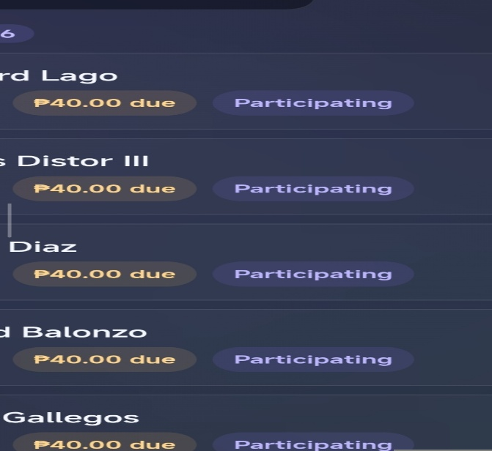
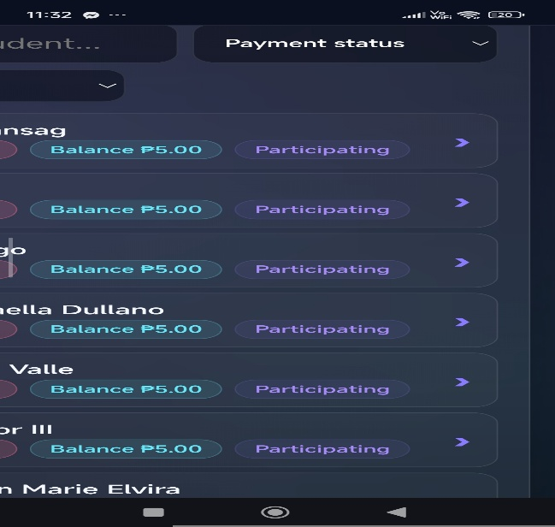
- Change only the color of “balance ₱5.00” into like this 2nd photo, then change also the “participating” color into like 2nd photo, again just color only, this is in the student page located.
  - Don’t change the “balance ₱x.xx” into “₱x.xx due”, again don’t change, just the color i want to change.
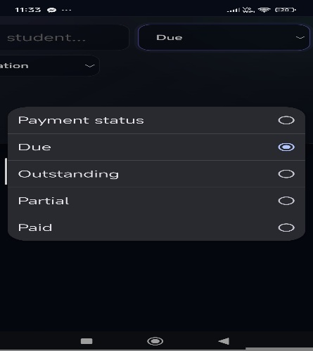
- change the text “due” to “due today” thats it, this located in student page- payment status.

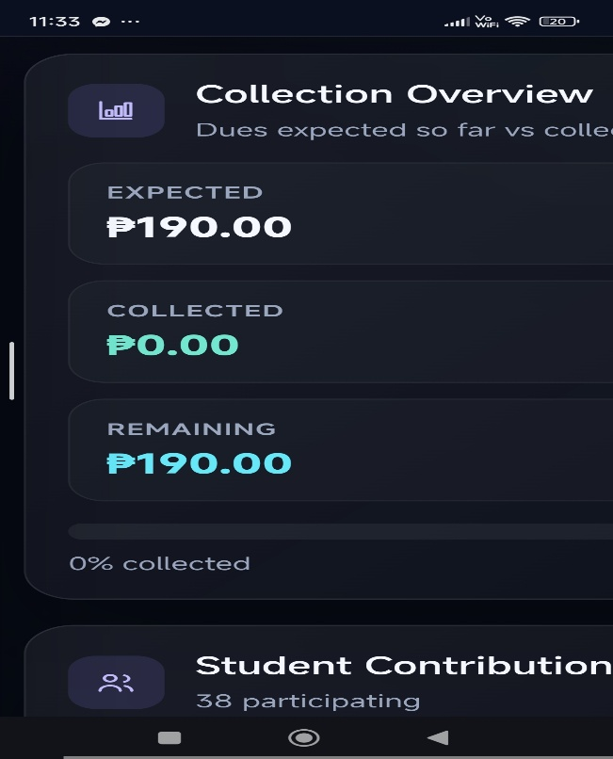
- I want the color of 2nd photo in “remaining” this should emphasize/complementing the color of balance of students “ex. balance ₱5.00” which i want to change in the number 1 also instead of blue accent. This located in reports page

